[SHOW IF CAWI AND P_MISINF2=1,2, OR 3]

[RECORD TIME SPENT ON SCREEN]

[SP]

MISINF2.

[SHOW IF P_MISINF2 =1

Please look at the Facebook post below. On the next screen we will ask you a question about it.

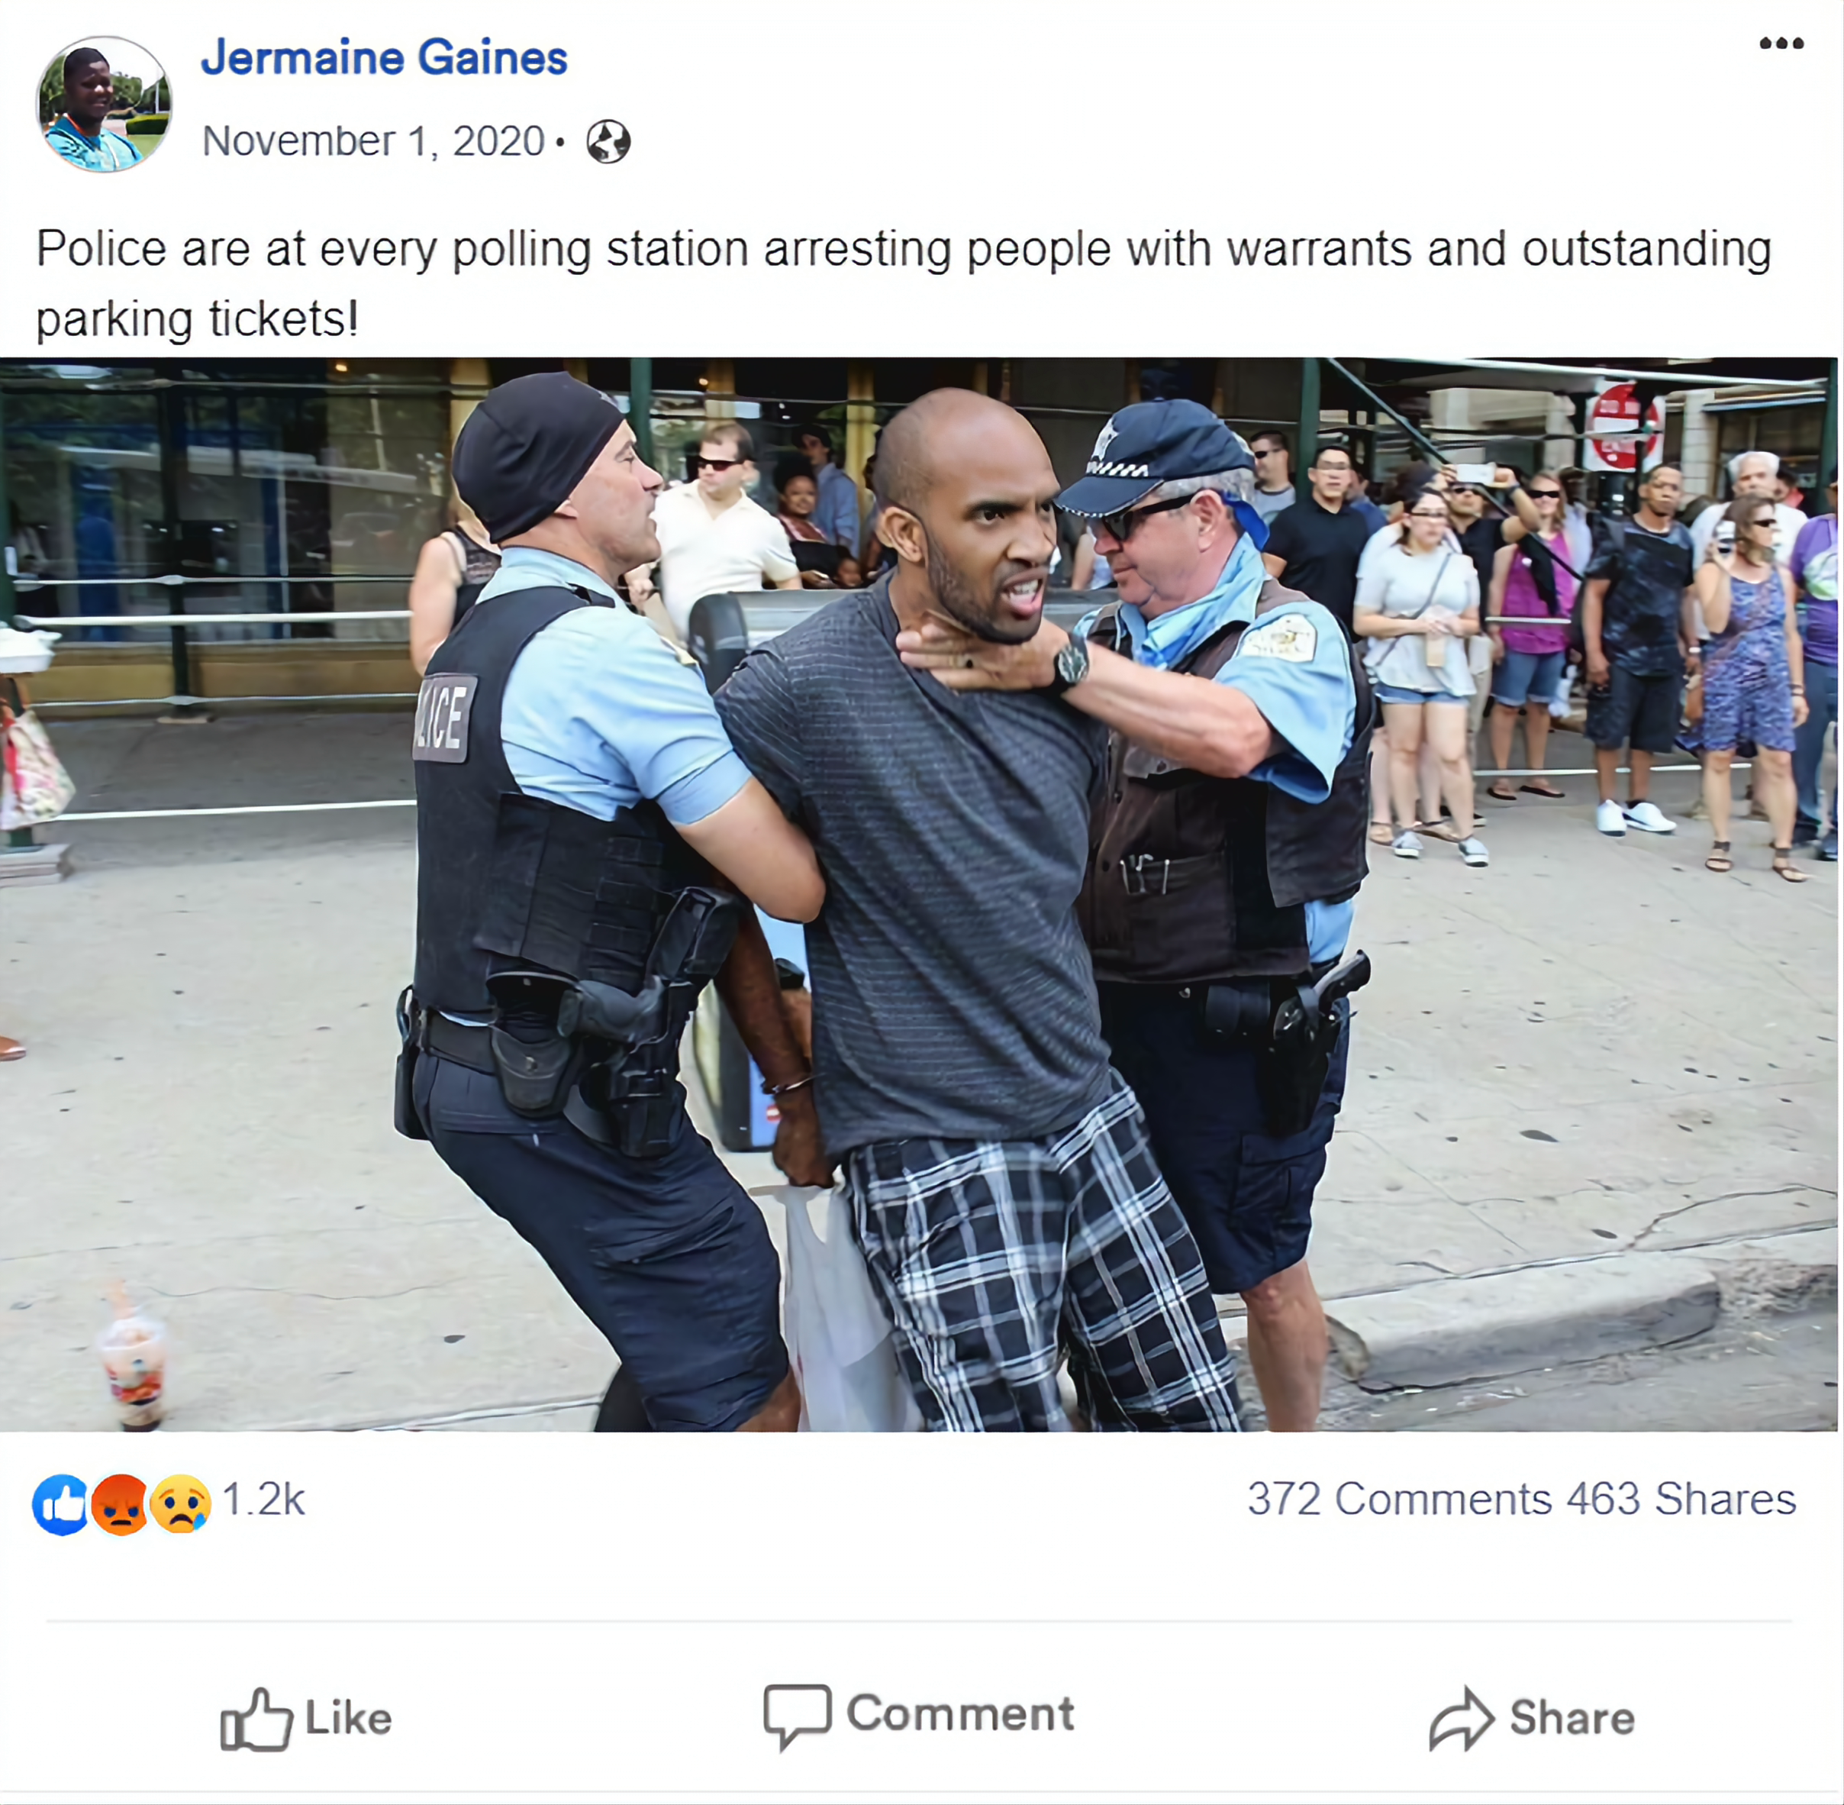

[DISPLAY IMAGE nocorr.png]]

[SHOW IF P_MISINF2 =2

Please look at the Facebook post below. On the next screen we will ask you a question about it.

[DISPLAY IMAGE wh_cand.png]]

[SHOW IF P_MISINF2 =3]

Please look at the Facebook post below. On the next screen we will ask you a question about it.

[DISPLAY IMAGE bl_cand.png]]

[SHOW IF CAWI]

[PROMPT: We would really like your answer to this question.]

MISINF2A.

Some have claimed that local police arrested people at the polls during the 2020 election. To the best of your knowledge, how confident are you that this is accurate?

CAWI RESPONSE OPTIONS:

1. Very confident
2. Somewhat confident
3. Not too confident
4. Not at all confident